Apply SQL Server patches in SQL Server Always On Availability Group Replicas

First, we apply the patch on the secondary replica of the primary data center.

* If the Failover Mode is not set to Manual, open the availability group properties in SSMS and change the failover mode from Automatic to Manual like the below screenshot. It ensures that no automatic failover happens to the secondary replica in case of any issue on the primary replica while we apply the patches

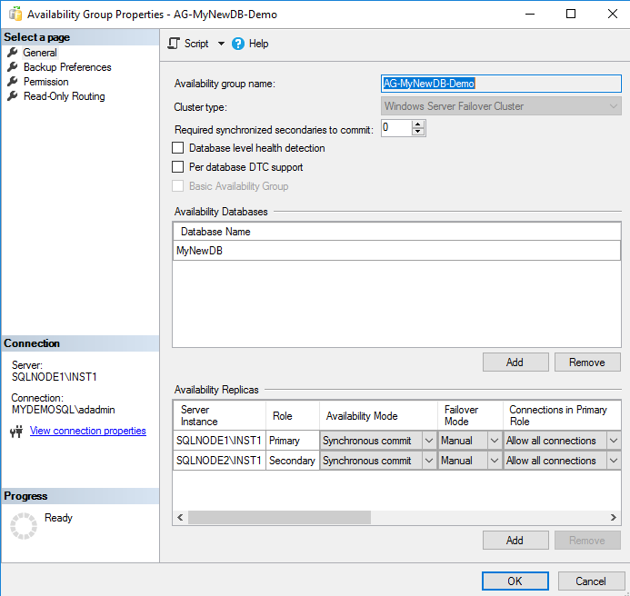

* Connect to the secondary replica in SSMS and Expand Always On High Availability-> Availability Databases. Suspend data movement for the secondary replica databases so that the primary replica does not send any transaction block to the specific secondary replica. If you suspend the data movement from the primary replica, it suspends data movement for all secondary replicas. Therefore, you should do it from the secondary replica in which you are applying the SQL Server Patches

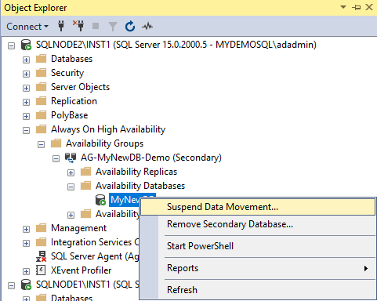

* Connect to the VM of the secondary replica and apply the service pack\cumulative pack as required. The installation service pack or cumulative pack is straightforward. You can follow the installation wizard and apply the latest patch.
* Restart the secondary replica. You must restart the server after applying the latest patches
* Once the secondary replica comes online, connect to it using SSMS and perform validation
  + Verify SQL Services are online
  + SQL Server version validation
  + Verify SQL Server error logs for any errors, warnings
  + Databases validations
  + It is also recommended to perform a database consistency checker (DBCC CHECKDB) after applying the patches
* Now, resume data movement from the secondary replica database. The secondary replica might take time to come in the synchronized state because it applies all pending transaction blocks on the secondary database before changing status to synchronize
* Wait for the AG dashboard to become healthy. Once it is green, perform a manual failover from the current primary replica to the secondary replica in the primary site
* After the failover, the current primary replica changes its state to a secondary replica. We can similarly apply the SQL Server patches by following the above steps
* Once the new secondary replica is also patched, and validations are done, perform an AG failback. After the failover, our availability group primary replica is the same before and after failover as well
* Change the failover mode to automatic for the primary and secondary replica in the synchronous data commit mode
* To this point, we have done the SQL Server pathing for the replicas in the primary site in SQL Server Always on Availability Group. You can ask application teams to start the validation and report for any issues
* The DR replica node is in asynchronous mode for SQL Server Always On Availability Group; therefore, it is already set to manual failover. Do the following steps
  + Pause the data movement from the DR replica node
  + Apply patch on the DR replica
  + Perform the database and SQL validation
  + Resume data movement

Post Patching work

Once you have applied SQL Server patches the SQL instances in an availability group, validate the following:

* Verify that you have the updated SQL Instance version on all replicas participating in SQL Server Always On Availability Group
* Perform AG failover and validate that the dashboard is healthy after failover and failback
* Review the error logs on all replicas
* Ask your application team to validate the functionality